# 

# MEET Y1 - Unit 2 - Lab Part 1

## Intro to Data Types

In this lab, you will learn about different data types, including **int**, **float**, **str**, and **bool**, and how to use **type()** to determine what data type something is using **Python** in **IDLE3**.

**Follow these instructions:**

0. In Google Docs, at the top left of your screen, click File > Download as > Microsoft Word … so that you can edit this lab document.

1. Fill in **column 2** of the table on the next page by writing what you would expect the output from **Python** to be. If you don't think Python can do something, write error. For example, if you did the first row, it would be like this:

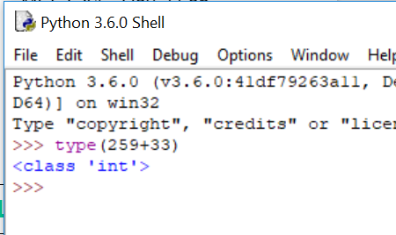

|  |  |  |
| --- | --- | --- |
| **Column 1** | **Column 2** | **Column 3** |
| **Expression** | **Your Guess** | **IDLE3 Output** |
|  | integer | int |
|  | float | float |
|  | integer | int |
|  | string | str |
|  | string | str |
|  | float | float |
|  | boolean | bool |
|  | error | error(not defind) |
|  | string | str |

2. Open **IDLE3** 

3. In the Python shell, type the code from **column 1** in each row, hit enter and write what the output is in **column 3**. Does it match what you thought the output would be?

**Lab 1 bonus:**

1. Think about why you got the errors with some lines. How can you change the line to get no error? Test your guess in the Python shell!

**The error hapend because we put two diffrent data-types we can solve the problem by making the word a string and changing the action to *.**

2. Now type all of the lines again without the word “type” at the beginning. What do you get?

292

226.0

4

‘4’

‘four’

2.5

True

Error

(‘colorcolorcolorcolor’)

3. If you have extra time, work on Unit 1 lab from yesterday or create your own design using turtle!